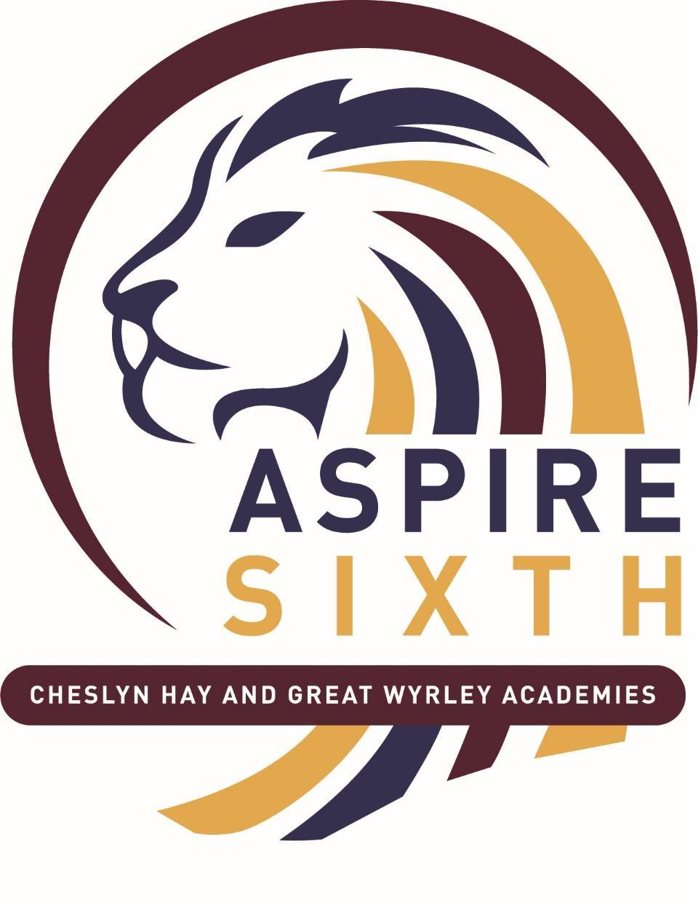 | ASPIRE Sixth  A part of Windsor Academy Trust  Headteachers:  Cheslyn Hay Academy- Ms. N Crookshank BA (Hons) MA NPQH  Great Wyrley Academy - Mr. Ian Moreton, BSc (Hons) NPQH | Saredon Road  Cheslyn Hay  Staffordshire  WS6 7JQ  Tel: 01922 416024  Email:  info@aspiresixth.windsoracademytrust.org.uk  Website; https://aspiresixth.windsoracademytrust.org.uk/  Twitter: @aspiresixth  Company registration no: 07523436  Place of registration: England

APPLICATION FOR THE 16-19 BURSARY FUND– CRITERIA ONE

Name

Address

Contact Number(s)

Tutor

Please circle all that apply:
- Looked After (in care)
- A care leaver
- Young person in receipt of Income Support or Universal Credit (UC) in their own right
- A disabled young person in receipt of both Disability Living Allowance (or Personal Independence Payments) and Employment Support Allowance (ESA) or Universal Credit as a replacement for ESA in their own right.

Please enter any comments relevant to your application and attach documentary evidence (photocopies are acceptable):

Please advise us below how you intend to use the grant to support your studies i.e. travel, meals etc:-

Please note all of the information on this application will be confidential but we may need to contact you or a parent/guardian for further information.
Payments for successful applicants will be paid by BACS in three instalments; October, January and April.

Student signature: Date:

Please return to: Mrs E Morgan, Head of 6th Form

